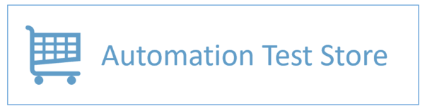

**Usability Feedback**

**________________________________________**

1. **User Interface (UI)**:
   * The design looks outdated and could benefit from modern styling for a better user experience.
   * Some buttons and text are too small and may not be easily clickable or readable for all users.
2. **Navigation**:
   * The menu is simple but lacks clear categorization, which can make it hard for new users to find specific products.
   * Adding a search bar would improve navigation and make it easier to locate items.
3. **Responsiveness**:
   * The site isn’t fully optimized for mobile devices, leading to poor usability on smaller screens.
4. **Functionality**:
   * Some product links and features might not work as expected since it’s a demo site.
   * Adding a clear message about its purpose as a test site could help users avoid confusion.
5. **Visual Appeal**:
   * A lack of images and appealing visuals for some products makes the site less engaging.
   * Consistent formatting of text and elements would improve the overall look.

### **Suggestions:**

* Upgrade the design to be more modern and mobile-friendly.
* Provide a better structure for categories and enhance search functionality.